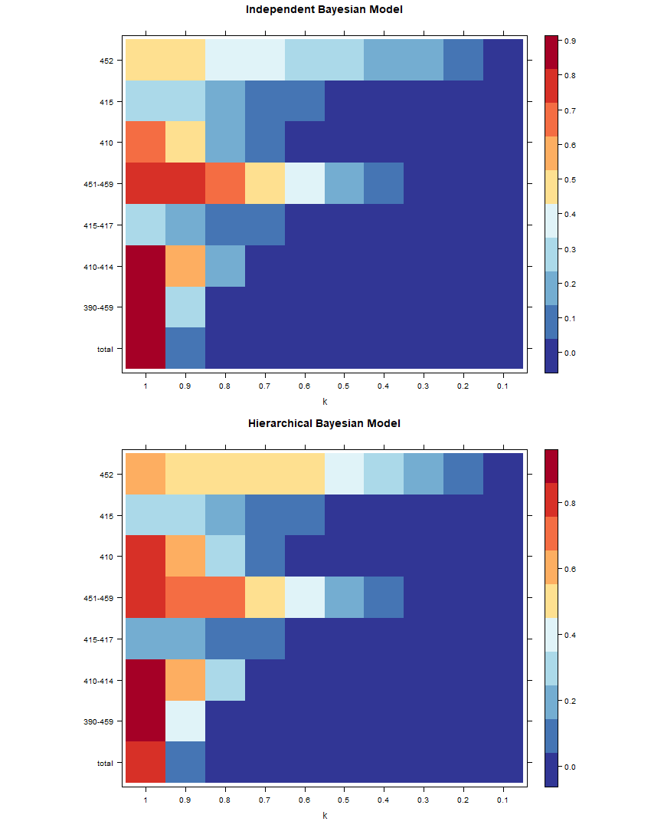

Figure 3.10: Heat-map of anomaly signals for ICD 410,415 and 452 and its ancestors, with no added anomalies, of IBM and HBM.

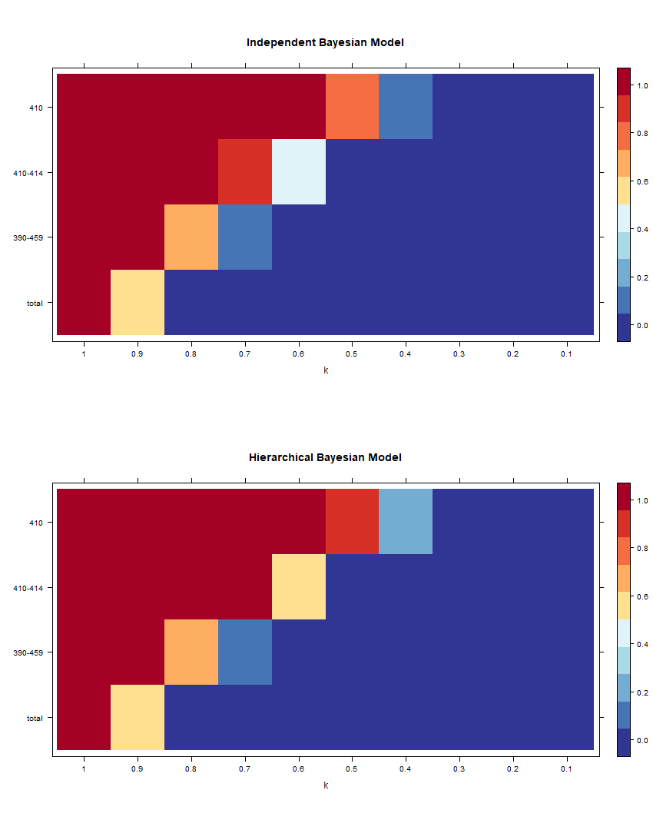

Figure 3.12: Heat-map of anomaly signals for ICD 410 and its ancestors, with no added anomalies, of IBM and HBM.

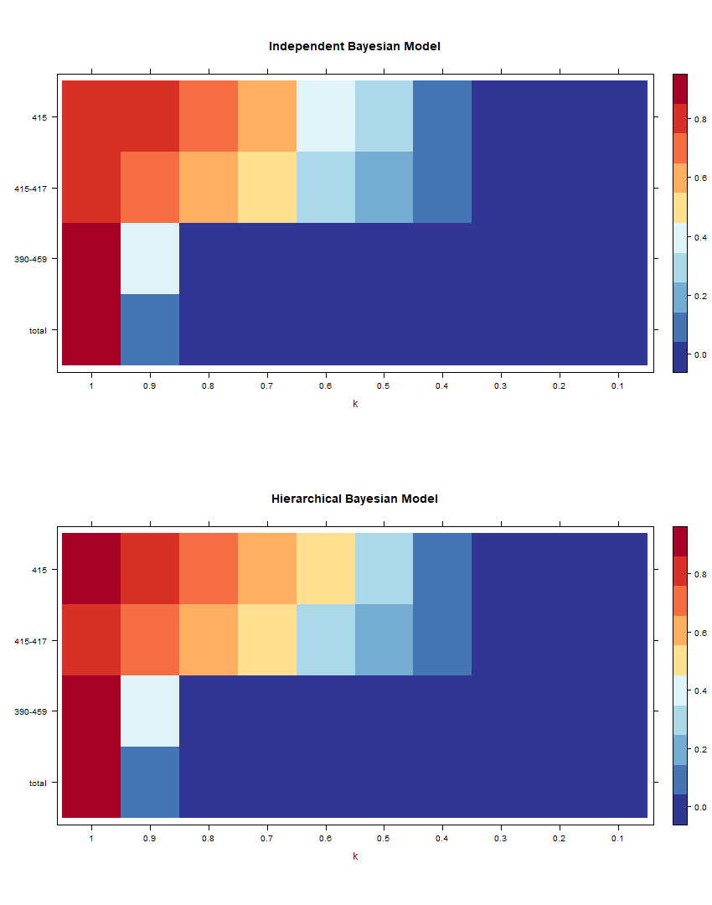

Figure 3.14: Heat-map of anomaly signals for ICD 415 and its ancestors, with no added anomalies, of IBM and HBM.

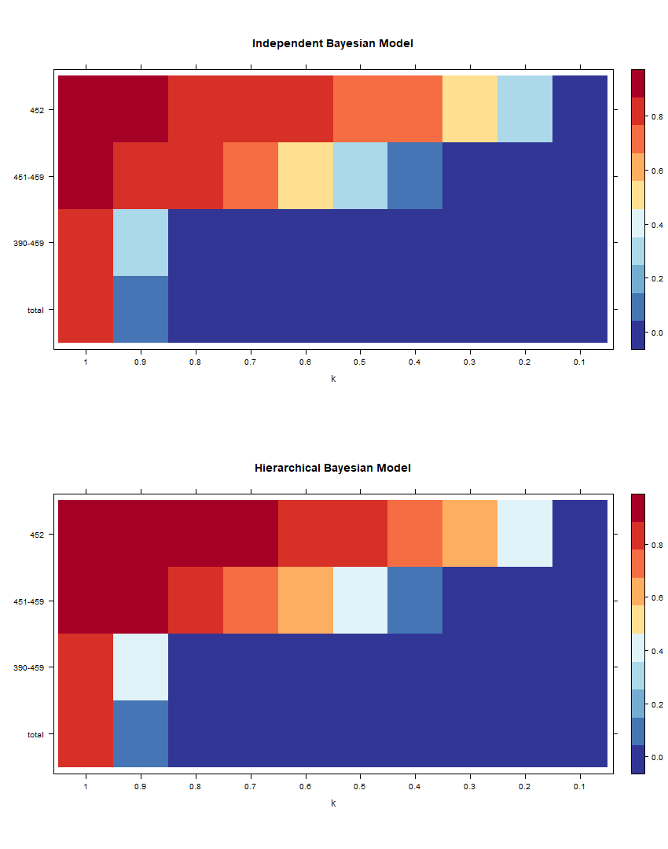

Figure 3.16: Heat-map of anomaly signals for ICD 452 and its ancestors, with no added anomalies, of IBM and HBM.